603-01 Fundamentals of Full Stack Web Development

TYBCA – SEM 6 (AY 2025-26)

Unit 1: Fundamentals of Angular (v17) for Single Page Applications 3
1.1 Angular Recap & Project Setup 3
1.1.1 Brief Recap of Angular 17 core concepts: Components, Services, Routing 4
1.1.2 Setting up a scalable Angular project using Angular CLI with Standalone Components 6
1.1.3 Folder structure and module organization for large projects 7
1.2 Advanced Routing & State Handling 7
1.2.1 Implementing Lazy Loading with Feature Modules 7
1.2.2 Route Guards: CanActivate, CanDeactivate for securing routes 8
1.2.3 Route Resolvers for preloading data 9
1.2.4 Introduction to advanced state handling using RxJS Subjects and Behavior Subjects 10
Summary Table 11
1.3 Reactive Forms in Real Applications 11
1.3.1 Dynamic form generation using FormArray 11
1.3.2 Custom Validators and Asynchronous Validation 12
1.3.3 Centralized error handling and displaying validation messages 13
1.3.4 Submitting forms to APIs and form state management 13
1.4 Building Reusable UI Components & Design Patterns 15
1.4.1 Creating reusable card, modal, and alert components 15
1.4.2 Component interaction with RxJS and Shared Services 16
1.4.3 Use of ng-template, ng-container, ng-content for structural flexibility 16
1.4.4 Smart vs Dumb Components: Best practices 17
1.5 Application Deployment & Performance Optimization 18
1.5.1 Angular build process, environments, and optimization flags 18
1.5.2 Deploying Angular applications using Firebase Hosting 19
1.5.3 Performance tuning: trackBy, OnPush change detection, lazy loading routes/components 20
Unit 2: Introduction to Express.js and Server-Side Basics with Node.js 22
2.1 Introduction to Node.js and Express.js 22
2.1.1 Installing Node.js (v20+) and setting up Express server 22
2.1.2 Creating a RESTful backend using Express.js 22
2.1.3 Introduction to nodemon and project structuring 23
Summary Table 24
2.2 Handling Routes and HTTP Methods 25
2.2.1 Defining routes using GET, POST, PUT, DELETE 25
2.2.2 Sending responses and working with route/query parameters 25
2.2.3 Connecting routes to controller logic 26
2.3 Middleware and API Basics 27
2.3.1 Understanding middleware in Express 27
2.3.2 Using built-in and custom middleware (e.g., body-parser, static files) 28
2.3.3 Introduction to CORS and environment variables 29
Summary Table 30
Unit 3: Building Web App Components and Backend Integration 31
3.1 Working with Forms and APIs 31
3.1.1 Handling form submissions in Express 31
3.1.2 Sending JSON responses and extracting request data 31
3.1.3 Connecting Angular forms to Express APIs 31
3.2 Organizing Code with Models and Controllers 31
3.2.1 Structuring backend with models, services, and controllers 31
3.2.2 Creating data models for users/products using MongoDB (Mongoose) 31
3.2.3 Basic CRUD operations using Express and MongoDB 31
3.3 Authentication and Security Basics 31
3.3.1 Introduction to Firebase Authentication (Email & Password) 31
3.3.2 Adding user registration and login to Angular frontend 31
3.3.3 Securing backend routes with Firebase Admin SDK and JWT 31
Unit 4: Firebase and React Integration 32
4.1 Firebase Firestore and Realtime Database 32
4.1.1 Setting up Firebase project and Firestore database 32
4.1.2 Performing basic CRUD operations on Firestore (add, read, update, delete) 32
4.1.3 Structuring collections and subcollections 32
4.2 Connecting Firebase with Angular and Express 32
4.2.1 Integrating Firebase SDK in Angular to fetch/store data 32
4.2.2 Connecting Firebase Admin SDK in Express for backend access 32
4.2.3 Basic deployment using Firebase Hosting (for frontend) 32
4.3 Overview of React Frontend for Full Stack Developers 32
4.3.1 Setting up a basic React app using Vite or Create React App 32
4.3.2 Understanding JSX, functional components, and hooks (useState, useEffect) 32
4.3.3 Integrating Firebase in a React app for data access and authentication 32

Unit 1: Fundamentals of Angular (v17) for Single Page Applications

1.1 Angular Recap & Project Setup

1.1.1 Brief Recap of Angular 17 core concepts: Components, Services, Routing
Angular is a platform and framework for building single-page client applications using HTML and TypeScript. Angular is written in TypeScript. It implements core and optional functionality as a set of TypeScript libraries that you import into your applications.
The architecture of an Angular application relies on certain fundamental concepts. The basic building blocks of the Angular framework are Angular components.
Components define views, which are sets of screen elements that Angular can choose among and modify according to your program logic and data
Components use services, which provide background functionality not directly related to views such as fetching data. Such services can be injected into components as dependencies, making your code modular, reusable, and efficient.
Components and services are classes marked with decorators. These decorators provide metadata that tells Angular how to use them.
The metadata for a component class associates it with a template that defines a view. A template combines ordinary HTML with Angular directives and binding markup that allow Angular to modify the HTML before rendering it for display.
The metadata for a service class provides the information Angular needs to make it available to components through dependency injection (DI)
An application's components typically define many views, arranged hierarchically. Angular provides the Router service to help you define navigation paths among views. The router provides sophisticated in-browser navigational capabilities.
Components
Every Angular application has at least one component, the root component that connects a component hierarchy with the page document object model (DOM). Each component defines a class that contains application data and logic, and is associated with an HTML template that defines a view to be displayed in a target environment.
The @Component() decorator identifies the class immediately below it as a component, and provides the template and related component-specific metadata.
Decorators are functions that modify JavaScript classes. Angular defines a number of decorators that attach specific kinds of metadata to classes, so that the system knows what those classes mean and how they should work.
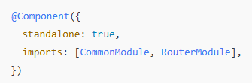
Templates, directives, and data binding
A template combines HTML with Angular markup that can modify HTML elements before they are displayed. Template directives provide program logic, and binding markup connects your application data and the DOM. There are two types of data binding:
Data bindings | Details
Event binding | Lets your application respond to user input in the target environment by updating your application data.
Property binding | Lets you interpolate values that are computed from your application data into the HTML.
Before a view is displayed, Angular evaluates the directives and resolves the binding syntax in the template to modify the HTML elements and the DOM, according to your program data and logic. Angular supports two-way data binding, meaning that changes in the DOM, such as user choices, are also reflected in your program data.
Your templates can use pipes to improve the user experience by transforming values for display. For example, use pipes to display dates and currency values that are appropriate for a user's locale. Angular provides predefined pipes for common transformations, and you can also define your own pipes.
Services and dependency injection
For data or logic that isn't associated with a specific view, and that you want to share across components, you create a service class. A service class definition is immediately preceded by the @Injectable() decorator. The decorator provides the metadata that allows other providers to be injected as dependencies into your class.
Dependency injection (DI) lets you keep your component classes lean and efficient. They don't fetch data from the server, validate user input, or log directly to the console; they delegate such tasks to services.
Routing
The Angular Router package provides a service that lets you define a navigation path among the different application states and view hierarchies in your application. It is modeled on the familiar browser navigation conventions:
- Enter a URL in the address bar and the browser navigates to a corresponding page
- Click links on the page and the browser navigates to a new page
- Click the browser's back and forward buttons and the browser navigates backward and forward through the history of pages you've seen
The router maps URL-like paths to components instead of pages. When a user performs an action, such as clicking a link, that would load a new component in the browser, the router intercepts the browser's behavior, and shows or hides that component (and its child components).
If the router determines that the current application state requires a component that hasn't been loaded, the router can lazy-load that component and its related dependencies.
The router interprets a link URL according to your application's view navigation rules and data state. You can navigate to new views when the user clicks a button or selects from a drop box, or in response to some other stimulus from any source. The router logs activity in the browser's history, so the back and forward buttons work as well.
To define navigation rules, you associate navigation paths with your components. A path uses a URL-like syntax that integrates your program data, in much the same way that template syntax integrates your views with your program data. You can then apply program logic to choose which views to show or to hide, in response to user input and your own access rules.
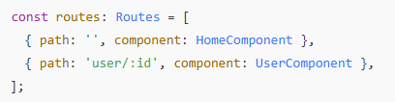

1.1.2 Setting up a scalable Angular project using Angular CLI with Standalone Components
Install the Angular CLI
You can use the Angular CLI to create projects, generate application and library code, and perform a variety of ongoing development tasks such as testing, bundling, and deployment.
To install the Angular CLI, open a terminal window and run the following command:
npm install -g @angular/cli@17
To create a new workspace and initial starter app:
- Run the CLI command ng new and provide the name my-app, as shown here:
ng new my-app
- The ng new command prompts you for information about features to include in the initial app. Accept the defaults by pressing the Enter or Return key.
The Angular CLI installs the necessary Angular npm packages and other dependencies. This can take a few minutes.
The CLI creates a new workspace and a simple Welcome app, ready to run.
Run the application
The Angular CLI includes a server, for you to build and serve your app locally.
Navigate to the workspace folder, such as my-app.
Run the following command:
cd my-app
ng serve –open
The ng serve command launches the server, watches your files, and rebuilds the app as you make changes to those files.
The --open (or just -o) option automatically opens your browser to http://localhost:4200/.
If your installation and setup was successful, you should see a page similar to the following.
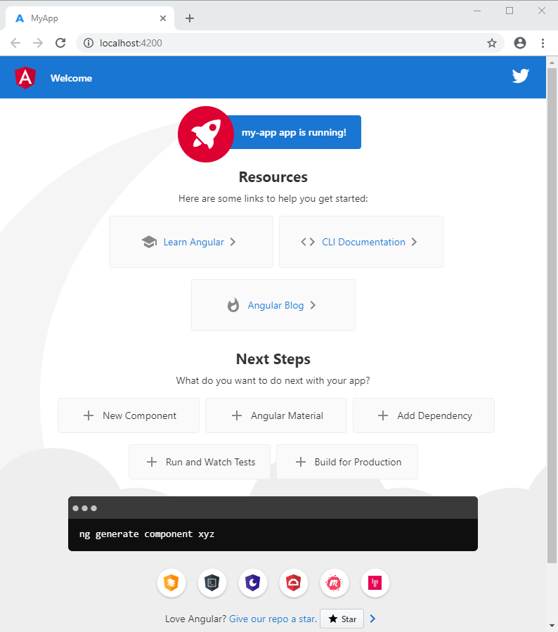

1.1.3 Folder structure and module organization for large projects
Workspace configuration files
All projects within a workspace share a CLI configuration context. The top level of the workspace contains workspace-wide configuration files, configuration files for the root-level application, and subfolders for the root-level application source and test files.
Workspace configuration files | Purpose
.editorconfig | Configuration for code editors.
.gitignore | Specifies intentionally untracked files that Git should ignore.
README.md | Introductory documentation for the root application.
angular.json | CLI configuration defaults for all projects in the workspace, including configuration options for build, serve, and test tools that the CLI uses, such as Karma, and Protractor.
package.json | Configures npm package dependencies that are available to all projects in the workspace.
package-lock.json | Provides version information for all packages installed into node_modules by the npm client.
src/ | Source files for the root-level application project.
node_modules/ | Provides npm packages to the entire workspace. Workspace-wide node_modules dependencies are visible to all projects.
tsconfig.json | The base TypeScript configuration for projects in the workspace. All other configuration files inherit from this base file. For more information

1.2 Advanced Routing & State Handling
Angular’s router and reactive state tools (RxJS) together allow you to build scalable, data-driven, and secure applications.

1.2.1 Implementing Lazy Loading with Feature Modules
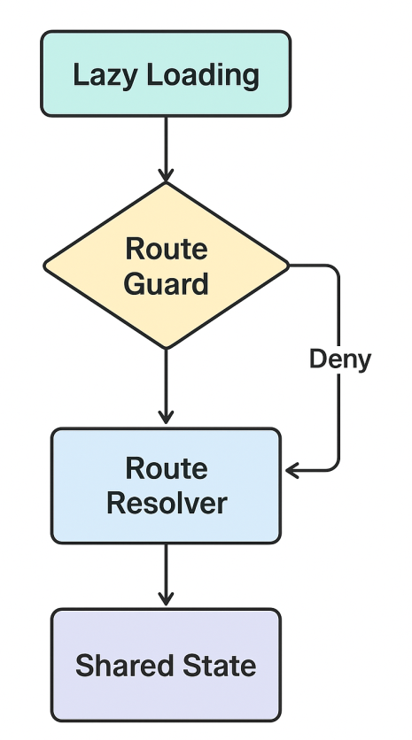
Goal: Load feature code only when a route is visited — improving initial load time.
In Angular 17 with standalone components, we use route-based lazy loading (no NgModules required).

Folder structure
src/app/
├── features/
│ ├── dashboard/
│ │ ├── dashboard.component.ts
│ │ └── dashboard.routes.ts
│ └── users/
│ ├── users.component.ts
│ └── users.routes.ts

🔹 app.routes.ts
import { Routes } from '@angular/router';

export const routes: Routes = [
{
path: 'dashboard',
loadChildren: () =>
import('./features/dashboard/dashboard.routes')
.then(m => m.dashboardRoutes)
},
{
path: 'users',
loadChildren: () =>
import('./features/users/users.routes')
.then(m => m.usersRoutes)
}
];

dashboard.routes.ts
import { Routes } from '@angular/router';
import { DashboardComponent } from './dashboard.component';

export const dashboardRoutes: Routes = [
{ path: '', component: DashboardComponent }
];
✅ Angular only loads the dashboard code when the user navigates to /dashboard.

1.2.2 Route Guards: CanActivate, CanDeactivate for securing routes
Goal: Control access to routes (authentication, unsaved changes, etc.)

Example: auth.guard.ts
import { Injectable } from '@angular/core';
import { CanActivateFn, Router } from '@angular/router';
import { AuthService } from '../core/services/auth.service';

export const canActivateAuth: CanActivateFn = (route, state) => {
const authService = inject(AuthService);
const router = inject(Router);
if (authService.isLoggedIn()) return true;
router.navigate(['/login']);
return false;
};

Example: unsaved.guard.ts
import { CanDeactivateFn } from '@angular/router';

export interface CanComponentDeactivate {
canExit: () => boolean;
}

export const canDeactivateGuard: CanDeactivateFn<CanComponentDeactivate> =
(component, route, state) => component.canExit();

Usage in Routes
export const routes: Routes = [
{
path: 'profile',
component: ProfileComponent,
canActivate: [canActivateAuth],
canDeactivate: [canDeactivateGuard]
}
];

In Component
export class ProfileComponent implements CanComponentDeactivate {
hasUnsavedChanges = true;
canExit() {
return !this.hasUnsavedChanges || confirm('Leave without saving?');
}
}

1.2.3 Route Resolvers for preloading data
Goal: Fetch required data before route activation, ensuring the component loads with data ready.

user.resolver.ts
import { ResolveFn } from '@angular/router';
import { inject } from '@angular/core';
import { UserService } from '../core/services/user.service';

export const userResolver: ResolveFn<any> = (route) => {
const id = route.paramMap.get('id');
return inject(UserService).getUserById(id!);
};

In Routes
export const routes: Routes = [
{
path: 'user/:id',
component: UserDetailComponent,
resolve: { user: userResolver }
}
];

In Component
import { ActivatedRoute } from '@angular/router';

export class UserDetailComponent {
user = this.route.snapshot.data['user'];
constructor(private route: ActivatedRoute) {}
}
✅ This ensures the user data is ready as soon as the component loads.

1.2.4 Introduction to advanced state handling using RxJS Subjects and Behavior Subjects
Goal: Share and react to state changes across multiple components without complex libraries like NgRx.

Understanding:
- Subject → emits data to multiple subscribers (no initial value).
- BehaviorSubject → same, but stores the latest value (good for UI state).

state.service.ts
import { Injectable } from '@angular/core';
import { BehaviorSubject } from 'rxjs';

@Injectable({ providedIn: 'root' })
export class StateService {
private _user = new BehaviorSubject<string | null>(null);
user$ = this._user.asObservable();

setUser(name: string) {
this._user.next(name);
}
}

Component A (sets state)
@Component({ ... })
export class LoginComponent {
constructor(private state: StateService) {}

login() {
// after successful login
this.state.setUser('Nehal');
}
}

Component B (reads state)
@Component({ ... })
export class DashboardComponent {
userName$ = this.state.user$;
constructor(private state: StateService) {}
}
In Template:
<p>Welcome, {{ userName$ | async }}!</p>
✅ Reactive state shared instantly across the app.

Summary Table
Concept | Purpose | Key API / Pattern | Benefit
Lazy Loading | Load code on demand | loadChildren | Faster load, modular
Guards | Secure routes | CanActivate, CanDeactivate | Prevent unauthorized access
Resolvers | Preload data | ResolveFn | Seamless data-ready routing
RxJS State | Reactive state sharing | Subject, BehaviorSubject | Simple global state management

1.3 Reactive Forms in Real Applications
Reactive Forms provide full programmatic control, making them ideal for dynamic forms, complex validation, and API integration.

1.3.1 Dynamic form generation using FormArray
Goal: Create dynamic fields (e.g., add/remove multiple addresses, phone numbers, etc.) at runtime.

Example: Dynamic Skills Form
import { Component } from '@angular/core';
import { FormArray, FormBuilder, Validators } from '@angular/forms';

@Component({
selector: 'app-skill-form',
standalone: true,
template: `
<form [formGroup]="form" (ngSubmit)="submit()">
<div formArrayName="skills">
<div *ngFor="let skill of skills.controls; let i = index">
<input [formControlName]="i" placeholder="Enter skill">
<button type="button" (click)="removeSkill(i)">Remove</button>
</div>
</div>
<button type="button" (click)="addSkill()">Add Skill</button>
<button type="submit">Submit</button>
</form>
`
})
export class SkillFormComponent {
form = this.fb.group({
skills: this.fb.array([this.fb.control('', Validators.required)])
});

constructor(private fb: FormBuilder) {}

get skills() {
return this.form.get('skills') as FormArray;
}

addSkill() {
this.skills.push(this.fb.control('', Validators.required));
}

removeSkill(i: number) {
this.skills.removeAt(i);
}

submit() {
console.log(this.form.value);
}
}
✅ FormArray enables dynamic, runtime form field creation with full reactive control.

1.3.2 Custom Validators and Asynchronous Validation
Goal: Extend validation logic beyond built-in validators.

Custom Validator (Synchronous)
import { AbstractControl, ValidationErrors } from '@angular/forms';

export function noSpecialChars(control: AbstractControl): ValidationErrors | null {
const valid = /^[a-zA-Z0-9 ]+$/.test(control.value);
return valid ? null : { invalidChars: true };
}

Async Validator (Example: check username availability)
import { AbstractControl, ValidationErrors } from '@angular/forms';
import { of } from 'rxjs';
import { delay, map } from 'rxjs/operators';

export function usernameTaken(control: AbstractControl) {
const taken = ['nehal', 'admin', 'root'];
return of(taken.includes(control.value)).pipe(
delay(500),
map(isTaken => (isTaken ? { usernameTaken: true } : null))
);
}

Usage in Form
form = this.fb.group({
username: ['', [Validators.required, noSpecialChars], [usernameTaken]]
});

1.3.3 Centralized error handling and displaying validation messages
Goal: Maintain cleaner templates and consistent error messages across components.

Shared Utility Service
@Injectable({ providedIn: 'root' })
export class FormErrorService {
private messages = {
required: 'This field is required',
invalidChars: 'No special characters allowed',
usernameTaken: 'Username already taken'
};

getError(control: AbstractControl | null): string | null {
if (!control || !control.errors || !control.touched) return null;
const firstError = Object.keys(control.errors)[0];
return this.messages[firstError];
}
}

In Component
@Component({ ... })
export class RegisterComponent {
form = this.fb.group({
username: ['', [Validators.required, noSpecialChars], [usernameTaken]]
});

constructor(private fb: FormBuilder, public formError: FormErrorService) {}
}

In Template
<input formControlName="username" placeholder="Username">
<small class="error">{{ formError.getError(form.get('username')) }}</small>
✅ Clean, reusable error messaging across the entire app.

1.3.4 Submitting forms to APIs and form state management
Goal: Handle form submission, disable while processing, and reset or display messages properly.

Example with HTTP
import { Component } from '@angular/core';
import { FormBuilder, Validators } from '@angular/forms';
import { HttpClient } from '@angular/common/http';

@Component({
selector: 'app-login-form',
standalone: true,
template: `
<form [formGroup]="form" (ngSubmit)="submit()">
<input formControlName="email" placeholder="Email">
<input type="password" formControlName="password" placeholder="Password">
<button type="submit" [disabled]="form.invalid || loading">
{{ loading ? 'Submitting...' : 'Login' }}
</button>
</form>
<p *ngIf="message">{{ message }}</p>
`
})
export class LoginFormComponent {
loading = false;
message = '';

form = this.fb.group({
email: ['', [Validators.required, Validators.email]],
password: ['', Validators.required]
});

constructor(private fb: FormBuilder, private http: HttpClient) {}

submit() {
if (this.form.invalid) return;

this.loading = true;
this.http.post('/api/login', this.form.value).subscribe({
next: () => {
this.message = 'Login successful!';
this.loading = false;
this.form.reset();
},
error: () => {
this.message = 'Login failed!';
this.loading = false;
}
});
}
}
✅ Handles all states:
- Disabled during submission
- Shows success/error messages
- Resets cleanly after response
Summary
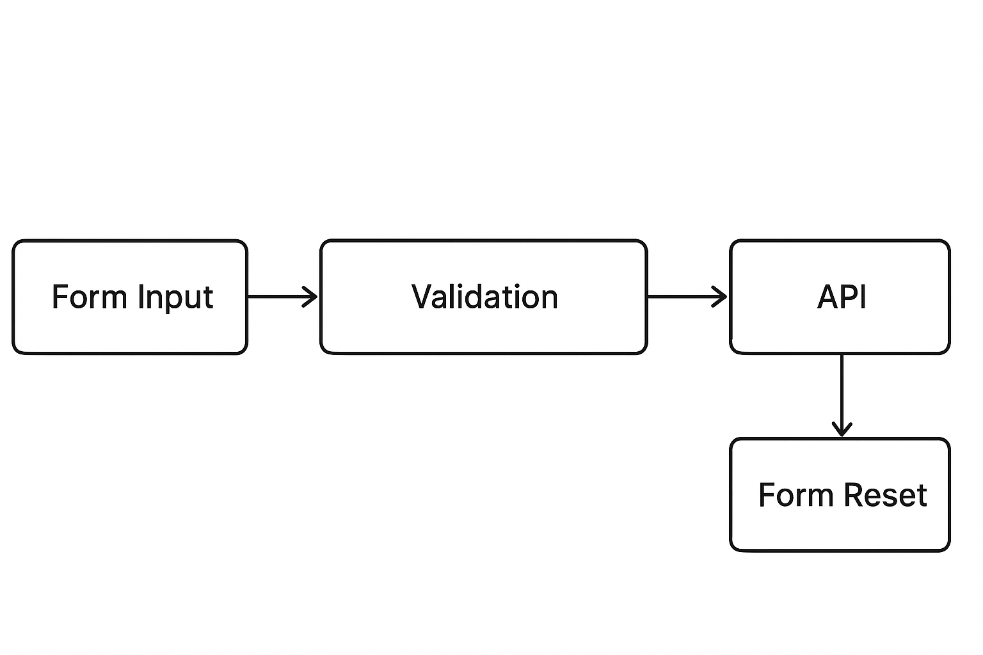
Concept | Purpose | Core Tools | Example Use
Dynamic Forms | Generate fields dynamically | FormArray | Skill list, multiple addresses
Custom Validators | Extend validation logic | Custom & Async validators | Username, password rules
Centralized Error Handling | Consistent error UI | FormErrorService | Clean templates
Form State & API | Handle submit lifecycle | HttpClient, FormGroup | Login, registration forms

1.4 Building Reusable UI Components & Design Patterns
Reusable components and design patterns are central to building scalable Angular applications. They ensure modularity, consistency, and maintainability across the project.

1.4.1 Creating reusable card, modal, and alert components
Concept:
Reusable components encapsulate both UI and logic to be used across multiple modules or pages.
Example:
- CardComponent → displays a title, content, and footer actions.
- ModalComponent → dynamic popup that accepts projected content.
- AlertComponent → shows success, warning, or error messages.
Key Steps:
- Create a shared module (SharedModule) or standalone components.
- Define @Input() and @Output() for customization and event communication.
- Use ng-content for flexible content projection.
Example:
@Component({
selector: 'app-alert',
standalone: true,
template: `
<div class="alert" [ngClass]="type">
<ng-content></ng-content>
<button (click)="close()">X</button>
</div>
`,
styles: [`.alert { padding:10px; border-radius:6px; }`]
})
export class AlertComponent {
@Input() type: 'success' | 'error' | 'warning' = 'success';
@Output() closed = new EventEmitter<void>();
close() { this.closed.emit(); }
}
Usage:
<app-alert type="error" (closed)="onAlertClosed()">
Invalid credentials. Please try again.
</app-alert>

1.4.2 Component interaction with RxJS and Shared Services
Concept:
Instead of using @Input() and @Output() deeply in component hierarchies, we can use RxJS Subjects or BehaviorSubjects in a shared service for communication.
Example: SharedService
@Injectable({ providedIn: 'root' })
export class SharedService {
private messageSource = new BehaviorSubject<string>('Hello');
message$ = this.messageSource.asObservable();

updateMessage(newMessage: string) {
this.messageSource.next(newMessage);
}
}
Component A (Sender):
this.sharedService.updateMessage('Data sent from Component A');
Component B (Receiver):
this.sharedService.message$.subscribe(msg => this.receivedMessage = msg);
✅ Advantage: Decouples components and promotes cleaner architecture.

1.4.3 Use of ng-template, ng-container, ng-content for structural flexibility
Directive | Purpose | Example
ng-template | Defines reusable HTML blocks not rendered by default. | <ng-template #loading>Loading...</ng-template>
ng-container | Groups elements logically without adding extra DOM nodes. | <ng-container *ngIf="isLoggedIn">Welcome!</ng-container>
ng-content | Projects external content inside a component. | <ng-content select=".header"></ng-content>

Example – Modal using ng-template:
<ng-template #modal let-data>
<div class="modal">
<h2>{{data.title}}</h2>
<p>{{data.message}}</p>
</div>
</ng-template>

1.4.4 Smart vs Dumb Components: Best practices
Type | Responsibility | Example
Smart Components (Container) | Handle business logic, state, and API calls | UserDashboardComponent
Dumb Components (Presentational) | Display data via @Input and emit events via @Output | UserCardComponent
Guideline:
- Smart components inject services, handle RxJS observables, and provide data to dumb components.
- Dumb components are purely UI-focused — reusable and testable.
Example:
// Smart Component
@Component({ ... })
export class UserListComponent {
users$ = this.userService.getUsers();
}

// Dumb Component
@Component({ ... })
export class UserCardComponent {
@Input() user!: User;
}
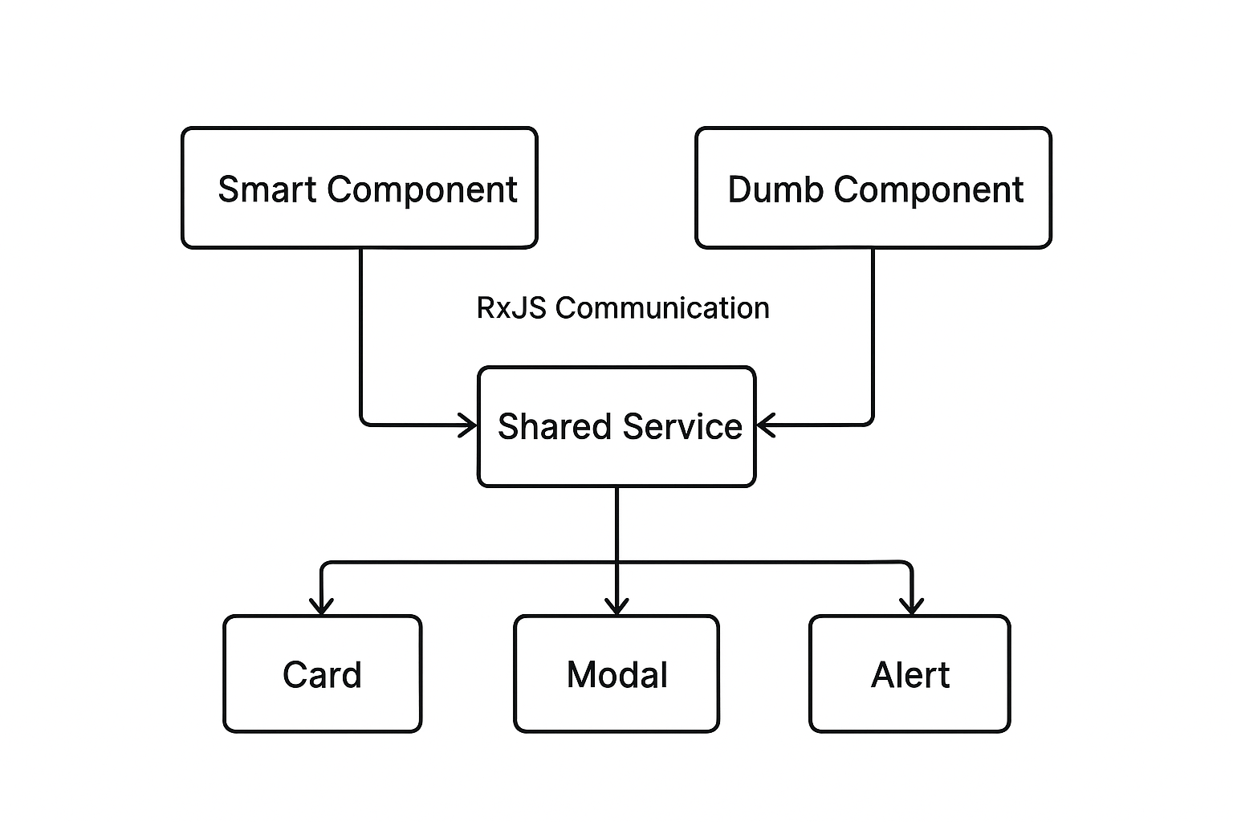

1.5 Application Deployment & Performance Optimization
Optimizing and deploying an Angular app involves preparing it for production with the right build settings, efficient hosting, and tuning techniques to improve speed and responsiveness.

1.5.1 Angular build process, environments, and optimization flags

Build Process Overview
Angular uses the Angular CLI build system (webpack under the hood) to compile, optimize, and bundle the app.
Steps (simplified):
- Transpile TypeScript → JavaScript
- Bundle all modules into chunks
- Optimize assets (HTML, CSS, JS)
- Generate a deployable dist/ folder
Command:
ng build --configuration production

Environment Configuration
Different builds (dev, staging, prod) can use environment files:
src/environments/environment.ts
src/environments/environment.prod.ts
Example:
export const environment = {
production: false,
apiUrl: 'http://localhost:3000/api'
};
Prod version:
export const environment = {
production: true,
apiUrl: 'https://api.myapp.com'
};
Angular.json configuration snippet:
"configurations": {
"production": {
"optimization": true,
"outputHashing": "all",
"sourceMap": false
}
}
Optimization Flags:
Flag | Description
--optimization | Minifies & tree-shakes the code
--aot | Ahead-of-Time compilation for faster runtime
--build-optimizer | Removes Angular decorators and unused code
--output-hashing=all | Cache-busting for browser reloads

1.5.2 Deploying Angular applications using Firebase Hosting
Steps to deploy:
- Install Firebase tools:
- npm install -g firebase-tools
- Login to Firebase:
- firebase login
- Initialize Firebase Hosting:
- firebase init hosting
  - Select your Firebase project
  - Set dist/<project-name> as the public directory
  - Choose "Yes" for SPA rewrite rules
- Build and Deploy:
- ng build --configuration production
- firebase deploy
Firebase Hosting Advantages:
- Free SSL certificate (https)
- Global CDN for fast content delivery
- Auto cache invalidation on deploy

1.5.3 Performance tuning: trackBy, OnPush change detection, lazy loading routes/components

a. Using trackBy with ngFor
Prevents re-rendering of unchanged DOM elements in lists.
Without trackBy:
<li *ngFor="let user of users">{{ user.name }}</li>
Every change re-renders the entire list.
With trackBy:
<li *ngFor="let user of users; trackBy: trackById">{{ user.name }}</li>

trackById(index: number, user: any) {
return user.id;
}
✅ Only modified items are re-rendered.

b. Change Detection Strategy: OnPush
Default strategy checks all components recursively.
OnPush limits checks to when @Input() values change or an observable emits.
@Component({
selector: 'app-user-card',
changeDetection: ChangeDetectionStrategy.OnPush,
template: `{{ user.name }}`
})
export class UserCardComponent {
@Input() user!: User;
}
✅ Reduces unnecessary re-rendering and boosts performance.

c. Lazy Loading Routes and Components
Load modules only when needed — improves initial load speed.
Example Route:
const routes: Routes = [
{ path: '', component: HomeComponent },
{ path: 'admin', loadChildren: () => import('./admin/admin.routes').then(m => m.ADMIN_ROUTES) }
];
Standalone component lazy loading (Angular 17):
{
path: 'profile',
loadComponent: () => import('./profile/profile.component').then(m => m.ProfileComponent)
}
✅ Reduces bundle size & initial load time.

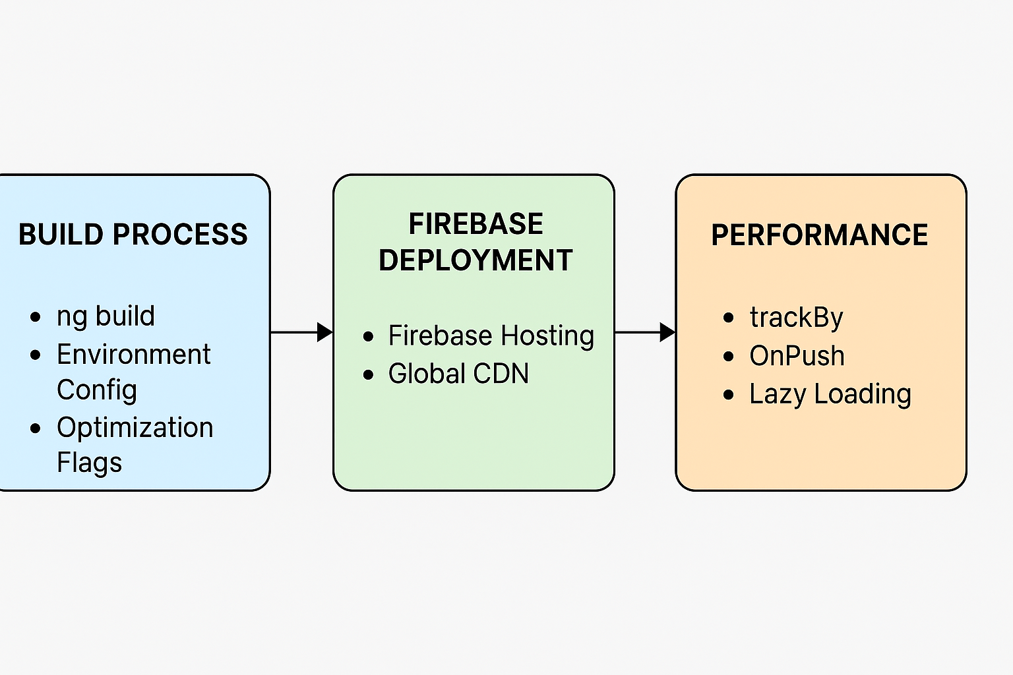

Unit 2: Introduction to Express.js and Server-Side Basics with Node.js

2.1 Introduction to Node.js and Express.js
Node.js is a JavaScript runtime built on Chrome’s V8 engine that allows you to run JavaScript on the server side.
Express.js is a minimal and flexible web application framework for Node.js that simplifies the process of building APIs and web servers.

2.1.1 Installing Node.js (v20+) and setting up Express server

1 Install Node.js
- Download from: https://nodejs.org
- Verify installation:
- node -v
- npm -v
(You should see versions like Node v20.x and npm 10+.)

2 Initialize a new project
mkdir my-express-app
cd my-express-app
npm init -y

3 Install Express.js
npm install express

4 Create a simple Express server
// index.js
const express = require('express');
const app = express();
const PORT = 3000;

app.get('/', (req, res) => {
res.send('Welcome to Express.js Server!');
});

app.listen(PORT, () => {
console.log(`Server is running on http://localhost:${PORT}`);
});
✅ Output:
Open http://localhost:3000 → “Welcome to Express.js Server!”

2.1.2 Creating a RESTful backend using Express.js
A RESTful API defines routes that handle CRUD (Create, Read, Update, Delete) operations over HTTP methods (GET, POST, PUT, DELETE).

Example: Simple REST API
const express = require('express');
const app = express();
app.use(express.json());

let students = [
{ id: 1, name: 'Nehal' },
{ id: 2, name: 'Amit' }
];

// READ: Get all students
app.get('/api/students', (req, res) => {
res.json(students);
});

// CREATE: Add new student
app.post('/api/students', (req, res) => {
const student = { id: Date.now(), name: req.body.name };
students.push(student);
res.status(201).json(student);
});

// UPDATE: Modify student by id
app.put('/api/students/:id', (req, res) => {
const student = students.find(s => s.id == req.params.id);
if (!student) return res.status(404).send('Student not found');
student.name = req.body.name;
res.json(student);
});

// DELETE: Remove student
app.delete('/api/students/:id', (req, res) => {
students = students.filter(s => s.id != req.params.id);
res.status(204).send();
});

app.listen(3000, () => console.log('Server running on port 3000'));
✅ RESTful Routes:
Method | Endpoint | Description
GET | /api/students | Get all students
POST | /api/students | Add new student
PUT | /api/students/:id | Update existing student
DELETE | /api/students/:id | Delete student

2.1.3 Introduction to nodemon and project structuring

1 Installing nodemon
nodemon automatically restarts your server when files change — essential for development.
npm install -g nodemon
Run with:
nodemon index.js
✅ No need to manually restart the server after every edit.

2 Recommended Project Structure
my-express-app/
│
├── node_modules/
├── src/
│ ├── routes/
│ │ └── studentRoutes.js
│ ├── controllers/
│ │ └── studentController.js
│ ├── app.js
│
├── package.json
└── README.md
Example – Modular Routing:
// src/routes/studentRoutes.js
const express = require('express');
const router = express.Router();
const { getAllStudents } = require('../controllers/studentController');

router.get('/', getAllStudents);
module.exports = router;
// src/controllers/studentController.js
exports.getAllStudents = (req, res) => {
res.json([{ id: 1, name: 'Nehal' }, { id: 2, name: 'Amit' }]);
};
// src/app.js
const express = require('express');
const app = express();
const studentRoutes = require('./routes/studentRoutes');

app.use('/api/students', studentRoutes);
app.listen(3000, () => console.log('Server ready on port 3000'));
✅ This modular design improves maintainability and scalability.

Summary Table
Concept | Description | Example
Node.js | JavaScript runtime for backend | Run server-side code
Express.js | Framework for REST APIs | app.get(), app.post()
nodemon | Auto-restart server on file changes | nodemon app.js
Project Structure | Organized folder layout | routes, controllers, etc.

2.2 Handling Routes and HTTP Methods

2.2.1 Defining routes using GET, POST, PUT, DELETE
Express provides methods to define routes corresponding to HTTP methods.
const express = require('express');
const app = express();
app.use(express.json()); // Middleware to parse JSON body

// GET → Fetch data
app.get('/students', (req, res) => {
res.send('Fetching all students...');
});

// POST → Add new data
app.post('/students', (req, res) => {
const newStudent = req.body;
res.send(`Student added: ${JSON.stringify(newStudent)}`);
});

// PUT → Update existing data
app.put('/students/:id', (req, res) => {
const id = req.params.id;
res.send(`Updating student with ID: ${id}`);
});

// DELETE → Remove data
app.delete('/students/:id', (req, res) => {
res.send(`Deleting student with ID: ${req.params.id}`);
});

app.listen(3000, () => console.log('Server running on port 3000'));
✅ Key Points:
- Each method corresponds to an HTTP verb.
- Routes can have parameters (:id) for dynamic handling.
- app.use(express.json()) allows parsing of JSON request bodies.

2.2.2 Sending responses and working with route/query parameters
Route Parameters (req.params)
Used for identifying resources dynamically (like user IDs).
app.get('/users/:id', (req, res) => {
const userId = req.params.id;
res.send(`Fetching user with ID: ${userId}`);
});
Query Parameters (req.query)
Used for filtering, sorting, or pagination.
app.get('/search', (req, res) => {
const { name, age } = req.query;
res.send(`Searching user: Name=${name}, Age=${age}`);
});
Sending Responses
- res.send() → Sends plain text or objects.
- res.json() → Sends JSON formatted data.
- res.status(code) → Sets HTTP status code.
Example:
app.post('/login', (req, res) => {
if (req.body.username === 'admin') {
res.status(200).json({ message: 'Login successful' });
} else {
res.status(401).json({ message: 'Unauthorized user' });
}
});

2.2.3 Connecting routes to controller logic
As the project grows, separating route definitions from business logic improves maintainability.
Structure Example:
project/
├── controllers/
│ └── studentController.js
├── routes/
│ └── studentRoutes.js
└── server.js
controllers/studentController.js
exports.getAllStudents = (req, res) => {
res.json([{ id: 1, name: 'John' }, { id: 2, name: 'Neha' }]);
};

exports.addStudent = (req, res) => {
const newStudent = req.body;
res.status(201).json({ message: 'Student added', student: newStudent });
};
routes/studentRoutes.js
const express = require('express');
const router = express.Router();
const studentController = require('../controllers/studentController');

router.get('/', studentController.getAllStudents);
router.post('/', studentController.addStudent);

module.exports = router;
server.js
const express = require('express');
const app = express();
const studentRoutes = require('./routes/studentRoutes');

app.use(express.json());
app.use('/students', studentRoutes);

app.listen(3000, () => console.log('Server running on port 3000'));

2.3 Middleware and API Basics
Middleware is the core concept of Express.js — it allows you to handle requests and responses at different stages of the server lifecycle.
It acts like a pipeline between the client request and the final response.

2.3.1 Understanding middleware in Express

What is Middleware?
Middleware functions are functions that have access to the request (req), response (res), and the next middleware in the application’s request–response cycle.
A middleware can:
- Execute any code
- Modify the req and res objects
- End the request-response cycle
- Call next() to pass control to the next middleware

Basic Example
const express = require('express');
const app = express();

// Middleware function (executes before routes)
app.use((req, res, next) => {
console.log(`${req.method} ${req.url} at ${new Date().toISOString()}`);
next(); // pass control to next middleware or route
});

// Sample route
app.get('/', (req, res) => {
res.send('Middleware demo running!');
});

app.listen(3000, () => console.log('Server on port 3000'));
✅ Key point:
Every incoming request passes through the middleware stack before reaching the route handler.

2.3.2 Using built-in and custom middleware (e.g., body-parser, static files)

1. Built-in Middleware
Express provides several built-in middleware functions for common tasks:
Middleware | Purpose
express.json() | Parses incoming JSON requests
express.urlencoded() | Parses URL-encoded form data
express.static() | Serves static files (images, CSS, JS)
Example:
app.use(express.json());
app.use(express.urlencoded({ extended: true }));
app.use(express.static('public'));
Now, files in the /public folder can be accessed directly, e.g.
👉 http://localhost:3000/images/logo.png

2. Custom Middleware
You can create custom middleware for:
- Logging
- Authentication
- Input validation
- API rate limiting
Example: Request Logger
function requestLogger(req, res, next) {
console.log(`[${req.method}] ${req.url}`);
next();
}

app.use(requestLogger);
Example: Auth Middleware
function authMiddleware(req, res, next) {
if (req.headers.authorization === 'Bearer secret123') {
next();
} else {
res.status(401).json({ message: 'Unauthorized' });
}
}

app.get('/secure', authMiddleware, (req, res) => {
res.send('Access granted!');
});
✅ Middleware can be global (app.use()) or applied to specific routes.

2.3.3 Introduction to CORS and environment variables

CORS (Cross-Origin Resource Sharing)
When a frontend (e.g., Angular app on http://localhost:4200) accesses a backend (e.g., Express API on http://localhost:3000),
CORS defines whether such cross-origin requests are allowed.
Install and Use:
npm install cors
Example:
const cors = require('cors');
app.use(cors()); // Allow all origins
Custom CORS Config:
app.use(cors({
origin: 'http://localhost:4200',
methods: ['GET', 'POST', 'PUT', 'DELETE']
}));
✅ Purpose:
Enables secure communication between frontend and backend across different domains.

Environment Variables
Store configuration values (like API keys, DB credentials, ports) outside the code for security and flexibility.
Step 1: Install dotenv
npm install dotenv
Step 2: Create .env file
PORT=4000
SECRET_KEY=mysecret
Step 3: Use in code
require('dotenv').config();

const express = require('express');
const app = express();
const PORT = process.env.PORT;

app.listen(PORT, () => console.log(`Server running on port ${PORT}`));
✅ Best Practice: Never hardcode secrets — always store them in .env (and ignore it in .gitignore).

Summary Table
Concept | Purpose | Example
Middleware | Functions to handle requests | app.use()
Built-in Middleware | Parse body, serve static files | express.json(), express.static()
Custom Middleware | Logging, Auth, Validation | app.use(logger)
CORS | Enables cross-domain requests | app.use(cors())
Environment Variables | Config separation | process.env.PORT

Unit 3: Building Web App Components and Backend Integration

3.1 Working with Forms and APIs

3.1.1 Handling form submissions in Express

3.1.2 Sending JSON responses and extracting request data

3.1.3 Connecting Angular forms to Express APIs

3.2 Organizing Code with Models and Controllers

3.2.1 Structuring backend with models, services, and controllers

3.2.2 Creating data models for users/products using MongoDB (Mongoose)

3.2.3 Basic CRUD operations using Express and MongoDB

3.3 Authentication and Security Basics

3.3.1 Introduction to Firebase Authentication (Email & Password)

3.3.2 Adding user registration and login to Angular frontend

3.3.3 Securing backend routes with Firebase Admin SDK and JWT

Unit 4: Firebase and React Integration

4.1 Firebase Firestore and Realtime Database

4.1.1 Setting up Firebase project and Firestore database

4.1.2 Performing basic CRUD operations on Firestore (add, read, update, delete)

4.1.3 Structuring collections and subcollections

4.2 Connecting Firebase with Angular and Express

4.2.1 Integrating Firebase SDK in Angular to fetch/store data

4.2.2 Connecting Firebase Admin SDK in Express for backend access

4.2.3 Basic deployment using Firebase Hosting (for frontend)

4.3 Overview of React Frontend for Full Stack Developers

4.3.1 Setting up a basic React app using Vite or Create React App

4.3.2 Understanding JSX, functional components, and hooks (useState, useEffect)

4.3.3 Integrating Firebase in a React app for data access and authentication

[Versions recommended: Node.js: v20 LTS or higher, Angular: v17+, Express: v4.x, Firebase: v10 SDK or latest (modular SDK)]
[ Students will submit E-Document for Project report. One internal guide will be allocated for every ten groups
All groups are required to contact their internal guides once a week to endorse their project progress work.][Students are required to complete this project by 10th of February/15th of August(for winter sessions) and submit].

